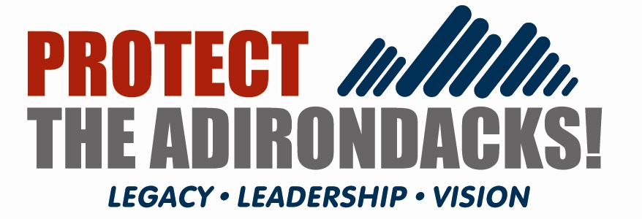

News Release

For Immediate Release: Monday, July 13, 2009

Contact: David Gibson, 518-377-1452
Charles Clusen, 202-289-2412
Robert Harrison, 518-359-2062
Lorraine Duvall, 518-576-9109
Dan Plumley, 518-576-4430

New Adirondack Environmental Group Launched at Meeting in Lake Placid

Lake Placid, NY – Following months of discussion and evaluation, the decision was made on Saturday, July 11 to formally consolidate the Association for the Protection of the Adirondacks with the Residents’ Committee to Protect the Adirondacks and to form a new organization called Protect the Adirondacks!

At their annual meeting last Saturday at Heaven Hill Farm outside the Village of Lake Placid, the memberships of both organizations voted in favor of consolidation, which enables the process to move through the final legal steps of incorporation. The membership of the Residents’ Committee voted 83-0 in favor of the consolidation. The membership of the Association voted 111-2 in favor. The positive vote of the memberships is the culmination of months of effort by the boards and staffs of the two parent organizations to build a strong case for consolidation.

Protect will maintain educational and administrative offices at its Center for the Forest Preserve in Niskayuna, and an Adirondack Park office and membership headquarters in Saranac Lake.

“Our decision to consolidate was driven primarily by the desire to sustain and strengthen New Yorker’s century-long efforts to secure the long-term health and vitality of the natural and human communities of the Park, now and in the years to come,” said incoming Board Chair Charles Clusen.

“Both groups firmly believed that since AFPA and RCPA were so complementary, we could create one new, larger, more efficient and effective organization – where the whole is truly greater than the sum of our two parts.” said Bob Harrison, incoming Vice Chair. “Thanks to this positive vote by our collective members, we now have that wonderful opportunity.”

“By joining forces as equal partners under the banner of Protect the Adirondacks!, we will capture a number of efficiencies and leverage our complementary resources to bring a high level of service, education and advocacy to bear on the range of challenges facing the Adirondacks and the Forest Preserve,” added Executive Director David Gibson.

The mission of the new organization is to be dedicated “to the protection and stewardship of the public and private lands of the Adirondack Park, and to build the health and diversity of its human communities and economies for the benefit of current and future generations. Protect the Adirondacks looks to a future in which the wild character, ecological integrity and mutual well being of the natural and human communities of the Park are sustained.”

Protect plans to break new ground in research and policy analysis, educational outreach, grassroots activism and hands-on contact with Park landowners and land managers to promote exemplary stewardship of Adirondack landscapes. Protect also plans to strengthen and expand existing programs in Forest Preserve protection and management, and in stewardship of the Park’s privately owned working forests, including such programs as the Sustainable Forestry and Adirondack Lake Assessment, and the Adirondack Park Stewardship Training.

Members of Protect’s Executive Committee are: Charles Clusen, Chair;
Lorraine Duvall, Robert Harrison and Dale Jeffers, Vice Chairs; David Quinn, Treasurer; Maryde King, Secretary; and Nancy Bernstein, Assistant Secretary.
-30-

